SALESBURY PARISH COUNCIL

NEWSLETTER 2024

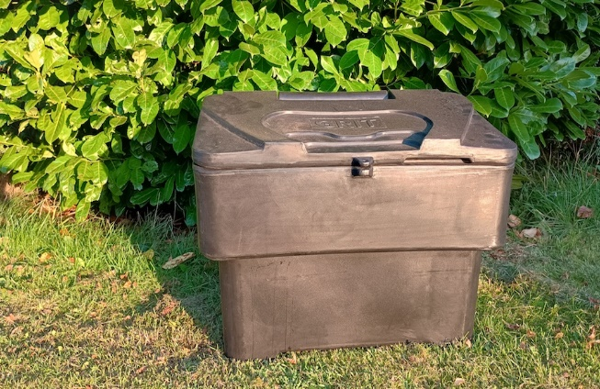

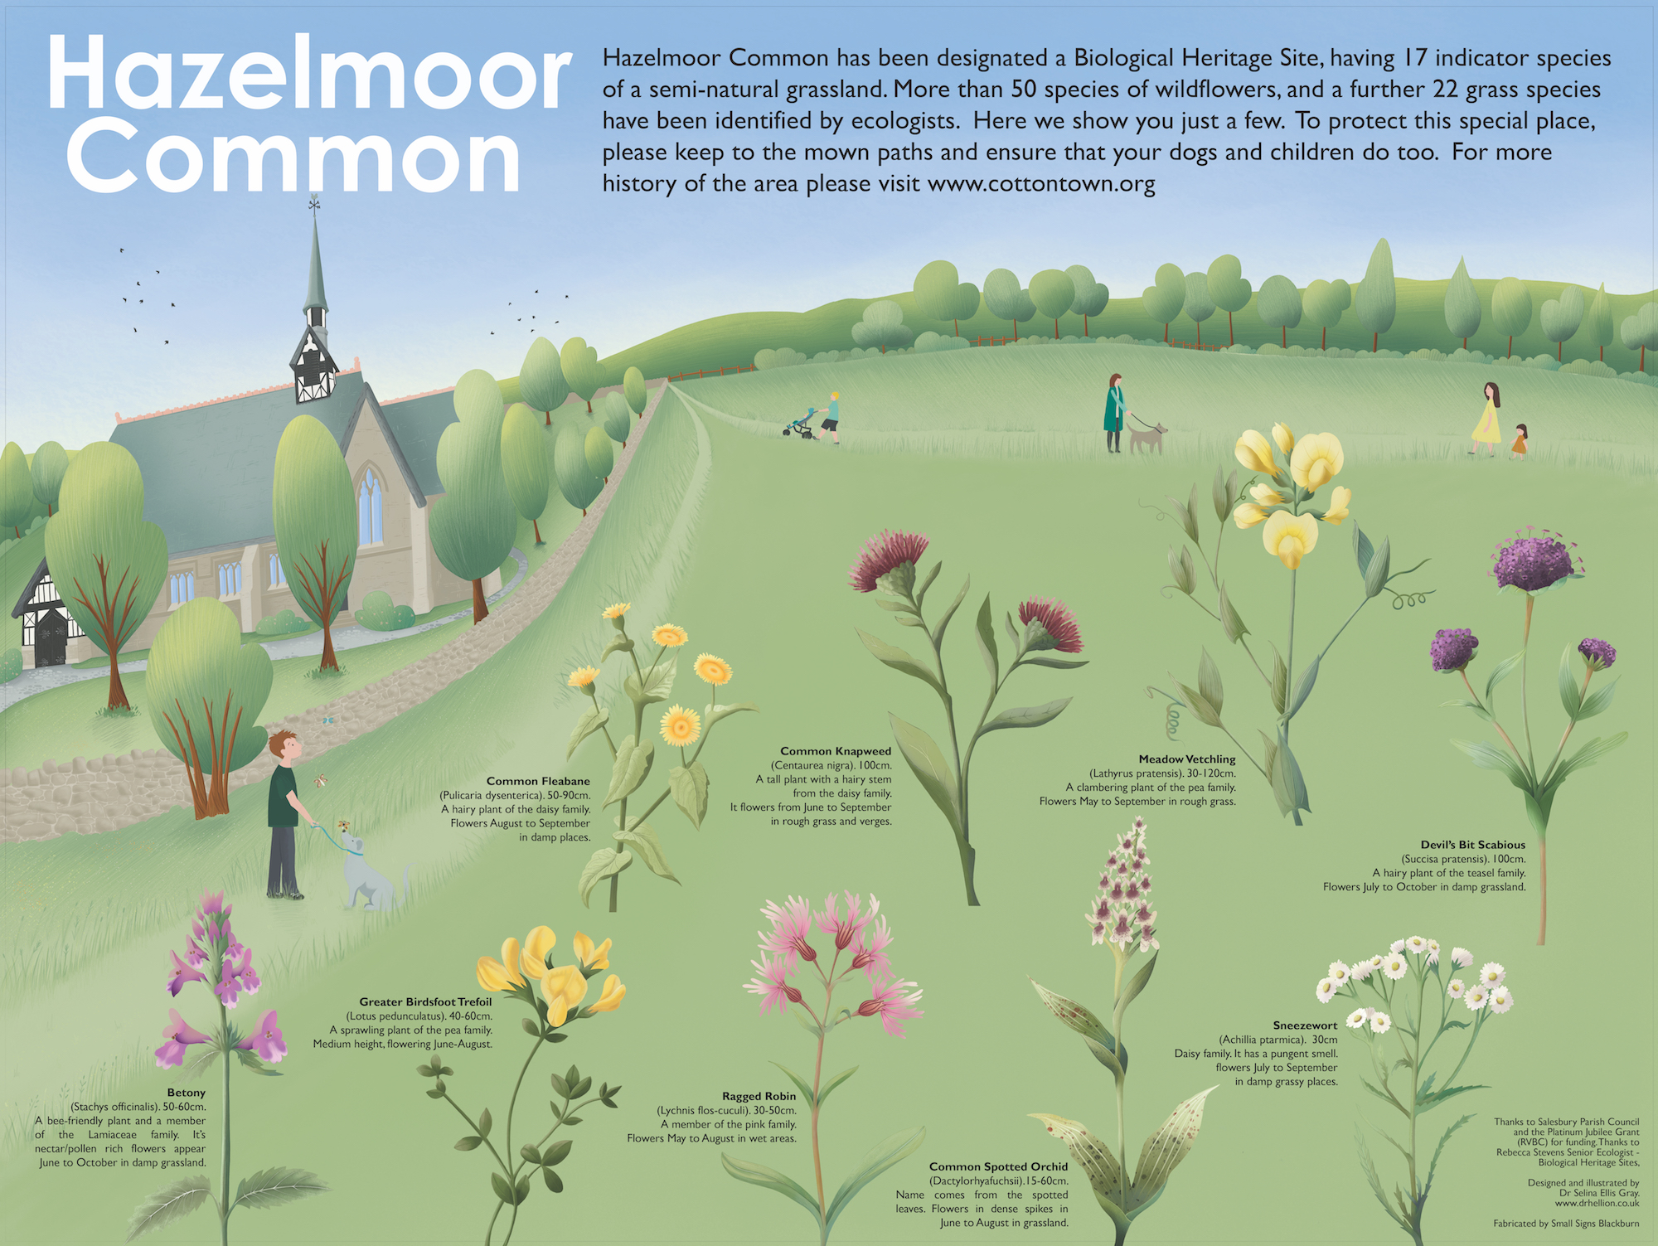

Welcome to the 2023/2024 Parish Newsletter which is aimed at giving you an insight into what your Parish Council has been doing during the past 12 months.
Graham Henderson, who was the Vice Chair, resigned in late July 2023. As a result of the vacancy, Maggy Howells was elected and re-joined the council. She was elected as Vice Chair at the meeting on 4th September 2023.
Maggy also became the Parish Champion which means she has the responsibility to liaise with Ribble Valley Borough Council on any issues relating to the Common Land within the Parish.

The current Councillors are:
Chris Booth email: cllrchrisbooth@gmail.com
Maggy Howells (Vice Chair) email: cllrmhowells@gmail.com
Janet Westwell email: cllrjanetwestwell@gmail.com
Tim Westwell
Mike Wood (Chair) email: cllrmwood@gmail.com

Lesley Lund (Parish Clerk) email: clerk@salesburypc.org.uk

I would like to extend a warm welcome to Phillip Bell who joined us as our new Lengthsman. He will undertake general maintenance around the Parish, for example keeping the footpaths along Lovely Hall Lane clear, ensuring the culverts on Lovely Hall Lane are kept clear.

During the past 12 months we have completed several fantastic projects all of which are covered in greater detail within this Newsletter. In addition to these we have also done the following:

- We removed the two planters from Hazel Moor due to lack of interest in their upkeep along with the one from opposite the Yu, this was removed to improve visibility. It was agreed at our meeting in September to remove the last remaining square planters leaving just the large one outside Oakleigh. The redundant planters will be offered for sale to any interested party.
- A ‘No Exit’ sign has been erected at the exit from Copster Green on to the A59 (opposite Pennine Cottage) to try to dissuade drivers from leaving Copster Green on what is a dangerous and blind corner.
- A Deer Crossing warning sign was requested by a resident, sadly Lancashire County Council didn’t give us permission to install one. Apparently drivers should be aware that there is always a risk of encountering deer on rural and semi rural roads.

- Residents annual survey - We had such a phenomenal response from the survey last year, we decided that we would continue working through the ‘to do’ list it generated and not do a survey this year. If you have any issues, questions or simply want to add to the list, please contact any Parish Councillor or our Clerk. For anyone who is interested, we are currently looking for volunteers to help us work through last years survey.

- As part of our efforts to try and keep the public rights of way through our Parish clearly marked, we will start to replace some of the old wooden way markers as soon as possible with composite alternatives. Lancashire County Council are kindly supplying them to us free of charge.

- We had plans to extend the path on the Ashes Farm side of Lovely Hall Lane, unfortunately this proved to be both difficult and costly. As such, a proposal to abandon the project was agreed at our Council meeting in May this year.

As Parish Councillors we give our time voluntarily to endeavour to enhance the Parish we all live in. A huge thanks to fellow councillors (both past and present) and to all who have been able to give us a helping hand along the way during the year. A special thanks also to Lesley Lund who does a superb job as our Parish Clerk, her guiding hand during the year has enabled the Parish Council to run smoothly, efficiently and effectively.
As always, if you would like further background on any Parish Council activity, please visit our website or contact any of us, we are here to serve you all as best we can.

SALESBURY MEMORIAL HALL
Our ‘Safer Access for Everyone (SAFE) Project
After a successful fundraising campaign to purchase the land in front of the hall and successful grant applications to Lancashire Environmental Fund and Ribble Valley Borough Council, Trustees are preparing to commence work on the driveway this autumn. This will provide a two-lane vehicular access for cars and designated, illuminated pedestrian walkways suitable for prams and wheelchairs. The entrance will also be considerably widened to provide safer departure from the hall’s estate.

SALESBURY MEMORIAL HALL


Salesbury Memorial Hall continues to host a variety of classes and events in the heart of the village.

Regular classes and events include:
- KT Fitness classes, every Monday, Tuesday and Thursday from 6pm.
Please contact Katie for more information: www.facebook.com/KTfitnesstraining
- Helen Carter Pilates – every Tuesday morning.
Please contact Helen for more information: helencarterpilates@yahoo.co.uk
- Ladies Badminton every Tuesday afternoon.
Please contact Susan: suejoyce78@gmail.com
- Mixed Badminton – every Wednesday evening.
Please contact Audrey for more information: audrey.pickup@yahoo.com
- Ribble Creative Stitchers – who meet the third Friday evening and all day Saturday.
Please contact Jane Holmes for more information: bushbabyjane@googlemail.com
- St Peter’s Mothers’ Union which meets the 4th Wednesday of the month.
Please contact Pamela Bridgford for more information: pamela.bridgford@gmail.com
- Fun with Flowers – frequent workshops throughout the year.
Please contact Sarah Kilbride for further information: sarahanddavekilbride@gmail.com
In addition, the hall hosts a full-service Post Office every Monday afternoon between 2.30pm – 4.00pm.
The hall also provides the perfect venue for private parties, wedding receptions, business meetings and community events.
We now offer online booking via our website https://www.salesburymemorialhall.com/programs using Hallmaster Online Hall and Venue Booking and Reservation System.

Garden fires – the rules
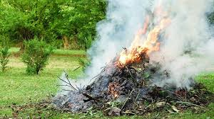
Be considerate!
If you do have to have a garden fire, and our advice is that you avoid them, make sure that the smoke will not head in the direction of neighbouring properties causing a nuisance.
Whilst it isn’t strictly against the law to burn rubbish in your own garden, there are laws around burning certain types of waste and to prevent bonfires causing a nuisance.
When it comes to disposing of waste, you should try to either compost or recycle as much as possible, so you don’t need to have a fire.
Where you have particularly heavy or bulky items, your local council should be able to take that away for you.
Rules around burning waste
You cannot burn waste if it will cause pollution or harm to people’s health.
RVBC has a duty to investigate any smoke coming from premises, such as from a bonfire, that could be classed as a statutory nuisance.
For the smoke to count as a statutory nuisance it must do one of the following:
- unreasonably and substantially interfere with the use or enjoyment of a home or other premises
- injure health or be likely to injure health
If they agree that a statutory nuisance is happening, has happened or will happen in the future, councils must serve an abatement notice. This requires whoever’s responsible to stop or restrict the smoke.
The notice will usually be served on the person responsible but can also be served on the owner or occupier of the premises.
Reporting a bonfire
If you see a bonfire that has gotten dangerously out of control, i.e. it is about to spread to a shed, fence or other property, you should call 999 and ask for the fire service.
Where you have a neighbour that is constantly burning, and this is having an impact on the quality of your life, you should contact your local council’s environmental health team.
**********************************************************************************
Protection of Hazel Moor Common
Parishioners have voiced their concerns for many years about the illegal parking of vehicles along the track leading across Hazel Moor to Salesbury Cricket Club and outside the clubhouse. The club committee have long tried to encourage both visitors and home supporters and players to park responsibly, however, there have still been drivers who refuse to comply with both their requests and local signage.
The council considered how best to prevent vehicles from parking on this protected grassland and during summer we were able to install large boulders along the edge of Hazel Moor Common. Sadly, the area nearest to the Cricket club had been significantly damaged by continued parking and application of gravel, so rather than trying in vain to restore the grassland to its former state, it was decided to concentrate our efforts on preventing further erosion.
We worked closely with Ribble Valley Borough Council, who are ultimately responsible for the management of the commons within the parish, to ensure the stones were acceptable and that necessary access for both waste vehicles and delivery wagons maintained.
We are delighted to have received many compliments about the boulders and they certainly seem to have been successful in preventing further damage.

Scambuster Stan & The Safe Traders Scheme

Did you know? Trading Standards now have a Facebook page where you can keep up to date with scam alerts and information about how to keep yourself safe from scammers;
information about product recalls of unsafe goods; allergen alerts relating to food; news
about trading standards matters and the Lancashire Safe Trader Scheme. Head over to
Facebook and follow the page for more information.
If you don’t use Facebook, you can find out more about how to keep yourself safe from telephone and doorstep scammers on Lancashire County Councils Trading Standards page at https://www.lancashire.gov.uk/business/trading-standards/ and consumer advice at https://www.lancashire.gov.uk/consumer-advice/


Lancashire County Council has partnered with local businesses to set up a Safe Trader Scheme. Traders agree to work with Trading Standards to resolve problems should they occur. Businesses on the scheme are monitored using customer feedback and have all demonstrated their commitment to fair and honest trading practices and delivering good customer service.
For small jobs, word of mouth from friends and neighbours is always a good way to find local businesses and individuals who should be happy to provide references and copies of relevant insurance details.

The Copster Green Community post Covid
The Covid pandemic ended up having an unexpected, but positive effect on the community at Copster Green. Following the regular coming together for the weekly Thursday NHS claps, residents have continued to enjoy locally organised informal events including celebrating Easter with bunny and egg hunts and Halloween by decorating their houses and gardens. Christmas has also been a special time with a life size Advent Calendar where 24 neighbours’ homes took it in turn to reveal a decorated window every day up to the big day itself. The first year, people enjoyed a walk round ‘The Green’ followed by carol singing by the parish council Christmas Tree. The carol singing has now become an annual event with the added bonus of sharing homemade mince pies and mulled wine. A date has yet to be set for this year, but everyone will be welcome!
National events such as the Platinum Jubilee and King Charles’ Coronation have also been celebrated with hugely successful picnics and games. By popular demand the games have led to another annual event – the Copster Green Boules Tournament! This year trophies were awarded in two categories with Jon Evans defending his win from last year and Jack Goodwin taking the inaugural under 16s trophy.

Calling All Dog Owners!
Following a number of incidents involving sheep worrying, police and farmers in the Ribble Valley are reminding dog owners to keep their dogs on leads when around livestock. Sadly this year many sheep and lambs have been killed or injured by loose dogs. No matter how friendly or docile you believe your dog to be, please keep it on a lead when livestock are around. Many fields are often interconnected and it is not always obvious when first entering a field whether cattle or sheep may be present.
We are lucky enough to enjoy miles of public footpaths in this area, but we all have a responsibility to the farmers whose land we cross. It is important to keep to the paths and to pick up after our dogs - especially in the fields- in order to prevent diseases being passed to livestock. Some parasitic infections carried in dog faeces can cause cattle to abort and sheep to die. If the parasite enters the animals’ food chain, for example by infecting hay fields, this can have a devastating effect on livestock and the farmers caring for those animals.
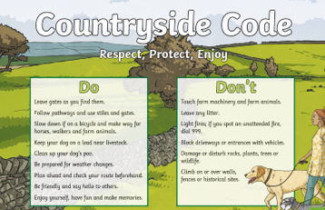

Parish Lengthsman
Earlier this year we were delighted to appoint our first contract for a Parish Lengthsman. Following an anonymous tendering process, where the councillors were unaware of the names of the tenders, the contract was awarded to Philip Bell, a local resident. After an successful initial 6-month period, this has now been extended for a further year.
What is a lengthsman? The term Lengthsman dates back to the Middle Ages and was the name given to a person responsible for the upkeep of a section or length of the highway. Nowadays it generally refers to someone who undertakes tasks at the request of the local council.
What will our lengthsman do? Within Salesbury Parish, we have several culverts, many miles of Public Rights of Way (PROWs), concessionary paths (e.g. the paths crossing through common land on Lovely Hall Lane) and large amounts of vegetation and hedging. Due to Government cuts over the last decades, much of the maintenance of these has been reduced or stopped altogether. In common with many other parishes, we have decided to allocate funds from the precept, together with grants, where available, to reintroduce this maintenance. In short, the Parish Lengthsman scheme is all about doing the little things that matter to our community and enabling those jobs to be carried out quickly and efficiently.
What has our lengthsman done so far? This year Philip has regularly dug out and maintained the culverts on Lovely Hall Lane to help reduce potentially dangerous flooding onto the highway, strimmed and tidied the vegetation along our most popular and well used public footpaths and areas not completed by the RVBC mowing team as well as cutting back hedges and vegetation blocking highway signs and roadside footpaths. We are also fortunate that Philip continues to give his time on a voluntary basis to assist councillors with the annual Christmas Tree displays and one-off events such as planning and supervising the placing the boulders on Hazel Moor Common.
In the future, we are hoping that tasks will also include working with local landowners to replace stiles, replacing some public footpath signs and keeping public rights of way clear. If you know of similar tasks needing to be done, please contact our Clerk, Lesley at clerk@salesburypc.org.uk

Ash Die Back and Non-Native Invasive Weeds
We’re very grateful to residents who have contacted us about the presence of these concerns within the Parish. We have reported these on to RVBC who are responsible for managing the common land. Their countryside officers are already actively managing cases of Japanese Knotweed & American Skunk Cabbage and have recently removed infected and dying ash trees along Lovely Hall Lane which posed a risk to walkers, paths and roads.
You may have noticed that Lancashire County Council have also been busy tackling ash die back along the A59 near Clitheroe. In partnership with the Treescapes Team and their grants, 500 native saplings have been planted to replace those lost. The Treescapes Team are currently doing some wonderful work in Lancashire parishes planting fruit orchards and Miyawaki forests. We hope to discuss whether they can work with us at a future meeting.
We are also aware of the encroachment of Himalayan Balsam onto areas of the commons and have asked our Lengthsman to strim this at the appropriate time of year. Whilst very pretty, this invasive species outcompetes our natural wildflowers and also destroys the stability of stream and river banks.
In the meantime, please do continue to report anything you spot.
Following a survey by Rebecca Stevens Senior Ecologist - Biological Heritage Sites, we wanted everyone to know about this special place. It is hoped that with this knowledge, people will not trample the plants, and will keep to the mown paths.

An information board was commissioned with flower paintings by an artist from Grindleton, and a fabrication company in Blackburn, thus keeping it local. There was a grant from LCC Parish Champion, to augment the funds from Salesbury Parish Council.

It has been much admired... this lady stopped by even before the workmen had cleared up after erecting it.

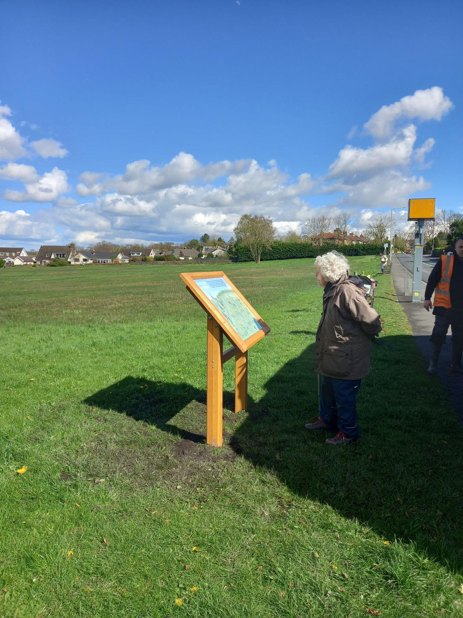

​The lecturn is sited next to Ribchester Rd, Southeast of the Church.
I also had a request from someone who used to live here, asking for a picture of it, as her photo hadn't turned out well.

​If anyone else would like the jpeg, just drop me a line, and I can send it on the understanding that it is only for your pleasure, not for commercial use.
cllrchrisbooth@gmail.com
SALESBURY LITTER PICK
On Saturday 4th May we had a "Salesbury Litterpick", which was well attended by young and old.
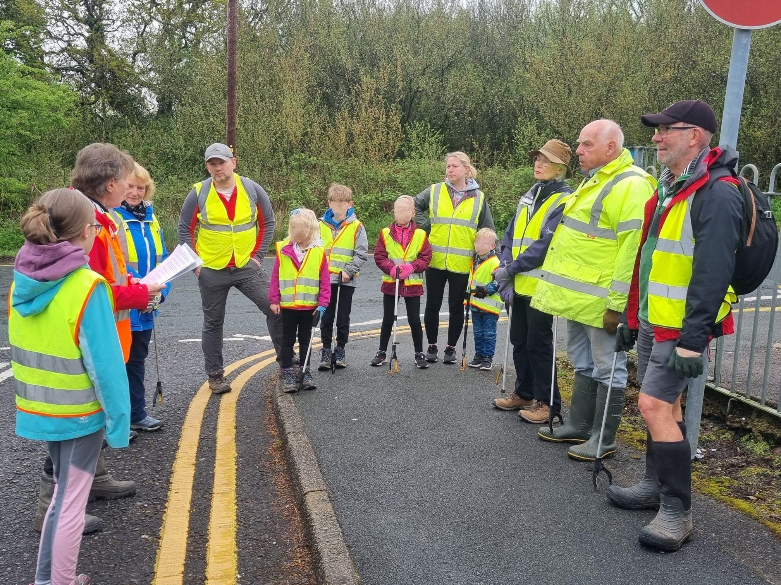

Thanks to local residents regularly doing their bit, there wasn't a huge amount to collect, so that was good to see.

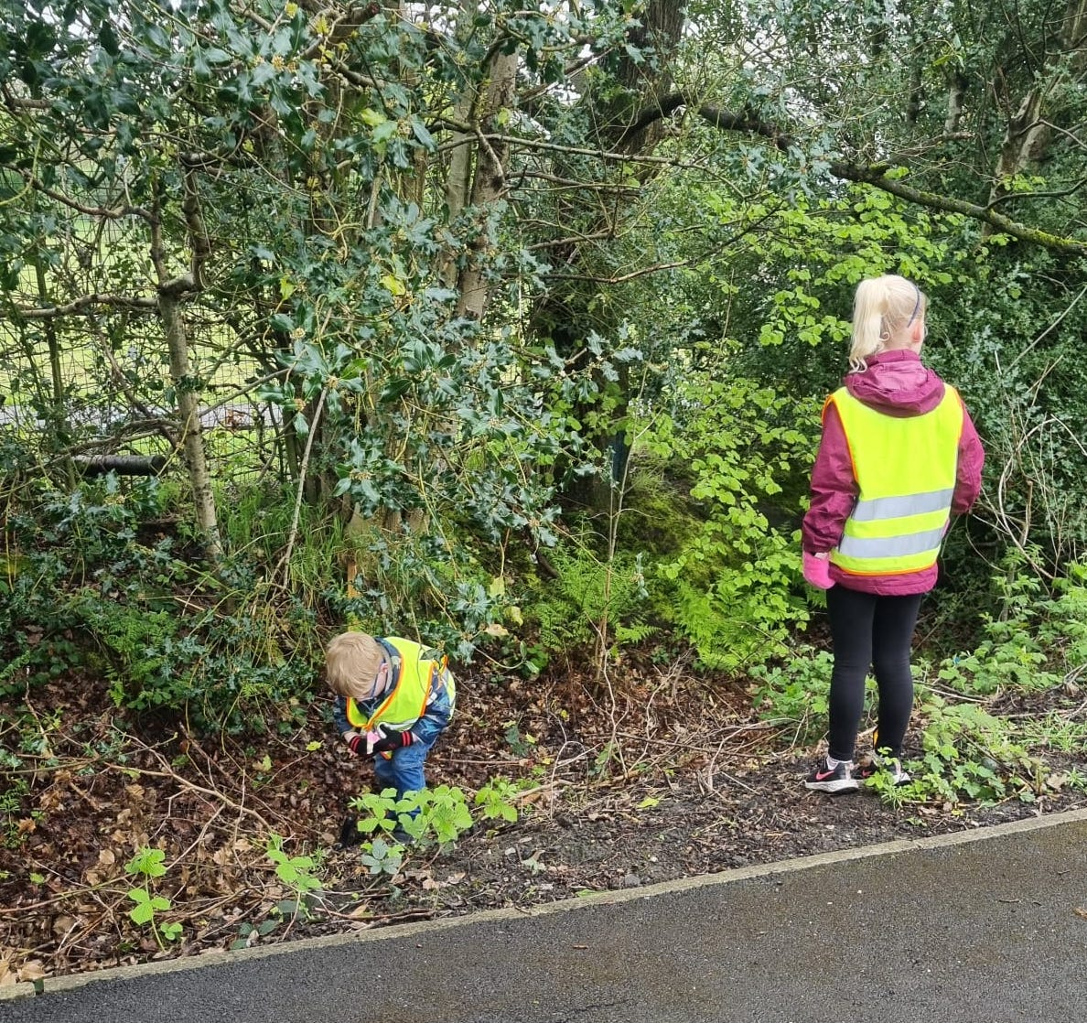

​We borrowed small Hi-viz jackets and "pickers" from school, and some members of school's Eco Group took part. Thanks also to RVBC for lending us adult jackets, litter pickers, hoops and bags.
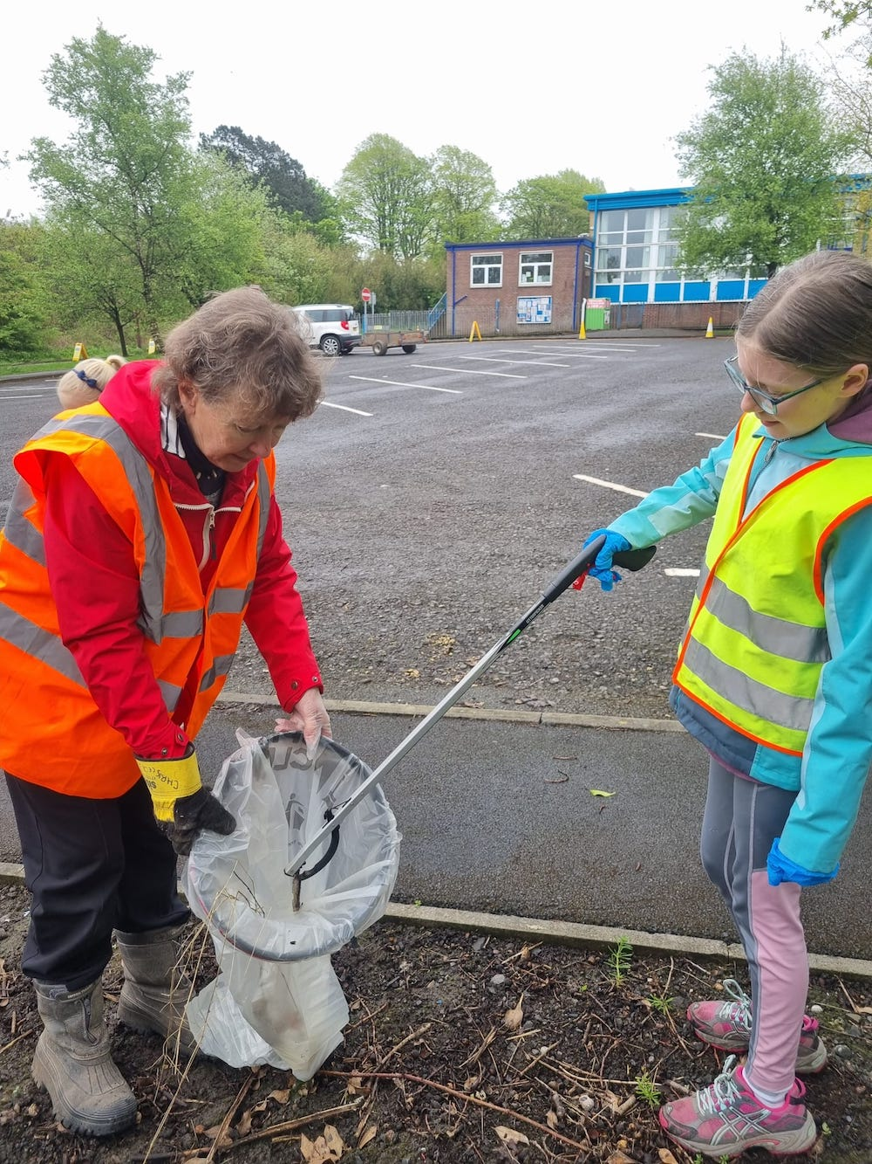

After about an hour, we all went up to the Memorial Hall for refreshments and to join SPC Councillor Janet Westwell and Maggie Howells and Ribble Valley Councillor L Edge (who since then has become Mayor).They were holding one of the regular "surgeries" where people who live in our area can raise any subject with someone from Salesbury Parish Council.

So many thanks to the dozen or so people who took part, and especially to the local residents who clear up litter week in, week out.
Chris Booth

Useful Links
Winter Preparation & Gritting
https://www.ribblevalley.gov.uk/parking-travel/winter-weather-gritting-1
Help for First Time Buyers in Ribble Valley
https://www.ribblevalley.gov.uk/housing/first-time-buyer-grant
Don’t Lose Your Vote
https://www.ribblevalley.gov.uk/news/article/267/don-t-lose-your-vote-check-and-confirm-your-annual-canvass-form

USEFUL CONTACTS

Salesbury Parish Council
The current Councillors are:
Chris Booth email: cllrchrisbooth@gmail.com
Maggy Howells (Vice Chair) email: cllrmhowells@gmail.com
Janet Westwell email: cllrjanetwestwell@gmail.com
Tim Westwell
Mike Wood (Chair) email: cllrmwood@gmail.com
Parish Clerk:
Lesley Lund email: clerk@salesburypc.org.uk

Website: http://www.salesburypc.org.uk/

Ribble Valley Borough Council
Council Offices, Church Walk, Clitheroe. BB7 2RA
Tel: 01200 425111
Website : https://www.ribblevalley.gov.uk/

Local Councillor: Louise Edge (cllr.louise.edge@ribblevalley.gov.uk)

Lancashire County Council
PO Box 78, County Hall, Fishergate, Preston. PR1 8XJ
Tel: 0300 123 6701
Website : https://www.lancashire.gov.uk/

Local Councillor: Alan Schofield (alan.schofield@lancashire.gov.uk)

Love Clean Streets
This free app can be downloaded to your computer, laptop or smartphone to report issues relating to potholes, flooding, pavements, highways, road signs, winter gritting and much, much more.
For more information go to https://www.lancashire.gov.uk/roads-parking-and-travel/report-it/report-it-on-the-go/
Or simply download the app via Google Play or the Apple App Store
Don’t just grumble…report it!

Grit Bins
Salesbury Parish Council had a request last year from local people for more grit bins.
We made the request to Lancashire County Council Highways (who are responsible for roads) for a bin on the steep bit near the bottom of Lovely Hall Lane, and one for the turn out onto the A59 from Park Gate Row which is difficult when icy.
Both were denied, and LCC said that they do grit Lovely Hall Lane, so we concentrated on getting a bin for Park Gate road. Residents did not want yellow, so we got a pretty little black one 

