

SALESBURY PARISH COUNCIL

NEWSLETTER
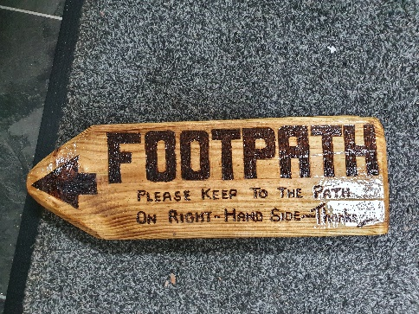
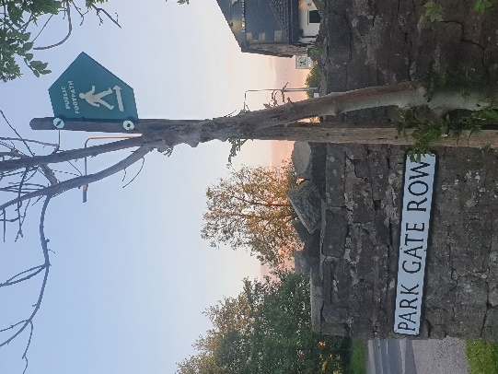
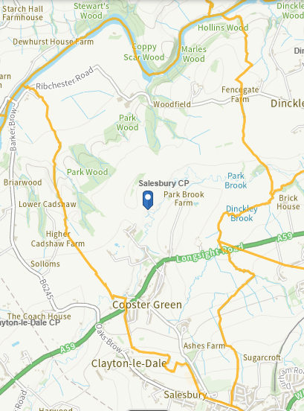
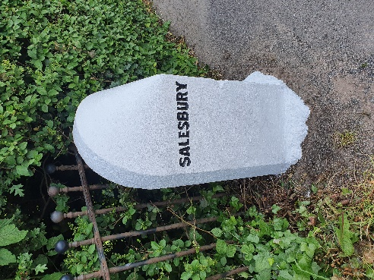

2022
Issue 3 SPC Newsletter

Introduction from the Chairman of the Parish Council
Welcome to the Summer 2022 Newsletter where we will give you an overview of what the Parish Council has been doing on your behalf. Firstly it has been a welcome return to face-to-face meetings, I would like to say that we did eventually get used to using Zoom, but I for one won’t miss it. We are now back to having our meetings in the Memorial Hall, as always if you are able to join us it would be great to see you, the dates and time of meetings will be published on our website along with notices on our noticeboards. Both are located on Lovely Hall Lane, one opposite Reds Hairdressers and one opposite the old nursery.
Since our last newsletter we have welcomed Chris Goodwin to the council, we have also lost Janet Westwell who resigned her position earlier this year. I would like to thank Janet on behalf of the Council. During her time as a parish councillor she brought many projects to the Council including the adoption by local residents of the planters saving the Council money spent on refilling them twice yearly.
Current Councillors and Clerk:
Chris Goodwin email: cllr.chris.goodwin@gmail.com
Graham Henderson email: cllrgrahamhenderson@gmail.com
Maggy Howells email: cllrmhowells@gmail.com
Mike Wood email: cllrmwood@gmail.com
Vacancy x 1 We would welcome expressions of interest from residents within the parish and also within 3 miles of the parish [in the Ribble Valley boundary] please contact the Clerk details below
Lesley Lund (Parish Clerk) email: salesburypc@gmail.com
We hope the information contained within this newsletter is of interest to you. You will also find information on our website please visit our new website: www.salesburypc or contact our Clerk, Lesley Lund at: salesburypc@gmail.com. Equally please feel free to contact any of your councillors directly (email addresses are on the website).
Finally I would like to thank my fellow councillors for their enthusiasm and for the enormous amount of their time freely given to enable the Parish Council to function over the last 12 months. I would also like to thank Lesley, our Parish Clerk who has worked above and beyond her call of duty.
Very Best Wishes
Mike

Salesbury and Copster Greens Management Committee
Following dialogue with officers from Ribble Valley Borough Council earlier this year it was established that the constitution of the Committee doesn’t allow it to make any management decisions. The Committee, which currently is made up of all 5 members of the Parish Council and 3 members of Ribble Valley Borough Council was only set up to advise and suggest on long term policy, not to manage. It was made clear that all the Common Land within the Parish is the responsibility of Ribble Valley Borough Council to both manage and maintain.
As a result, and with the support of Ribble Valley Borough Council we have agreed to suspend the Committee whist the situation is reviewed. In the interim, Maggy Howells will act as the ‘Commons Champion’ on behalf of the Parish and liaise directly with both officer and members of Ribble Valley Borough Council. This is something the Committee wasn’t able to do. It is acknowledged by both Ribble Valley Borough Council and the Parish Council that this interim arrangement will allow a more pro-active and agile relationship.
The Parish Council have been invited by Ribble Valley Borough Council to put forward proposals to ensure that it is able to influence and support, wherever possible, the day to day and long term management of the Commons.
If you are interested in any further background, the Parish Council minutes which are available on the website, would be worth reading.
Defibrillator Sessions
Together with Alison Meadows (AMTD 1st Aid) we ran 2 free C.P.R. and defibrillator awareness sessions at Salesbury Memorial Hall.
They were both very well subscribed and everyone who attended the sessions commented on how well the sessions were run.
The attendees felt confident in using the skills should they ever be faced with a Cardiac arrest.
Salesbury Parish Council covered the cost of the hall hire of £28.00 the next session will be held:
Venue: Salesbury Memorial Hall
Date: Monday 12th September
Time: 6pm - 9.30pm
Room: Large upstairs room

If you are interested in attending please email salesburypc@gmail.com or speak to one of the councillors.

Crumbling Wall Copster Green

After months of debate the Parish Council made the decision to remove the tree root [which was not on Common Land or the Bridleway] in order that the crumbling wall could be reinstated. Sadly this hasn’t happened yet but the Parish Council are of the understanding that a contractor is being sought to do the necessary works to the wall. Watch this space!
BEFORE AND AFTER
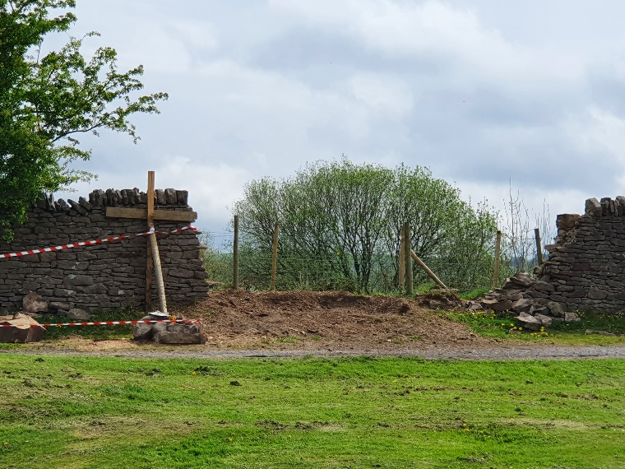
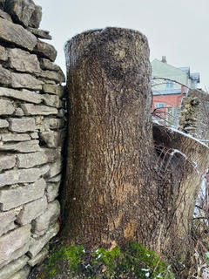
Financial £££
At the financial year end reserves were standing at a healthy balance of approximately £12144.46 however there are owed monies to pay from this amount so the true figure is less than twice the precept. As a result of the current reserves and possibility of applying for grants to help fund future projects it was agreed by the Parish Council not to increase the precept we receive from your Community Charge bills and decided to keep it at a total of £4,800 for the coming year.
The Parish Council can also claim back VAT which will be £190.17 during the financial year 2021/2022.
If you have any suggestions on any projects you would like us to consider spending your money on this coming year, please let us know.

Jubilee Pathway
You will have seen in the annual survey that we are hoping to create a new concessionary path near Ashes Farm, just off Lovely Hall Lane. This would link up with existing pathways to create a circular path that is fully accessible to prams and wheelchairs. Your responses were overwhelmingly in favour of this. However, before work can start, the land managers, RVBC need us to commission a variety of ecological surveys. These don’t come cheap, so we will be busy applying for grants to cover as much of these costs as possible. We also hope to take advantage of other grants to help with the cost of the new path itself plus improvements to the existing pathways in the area.

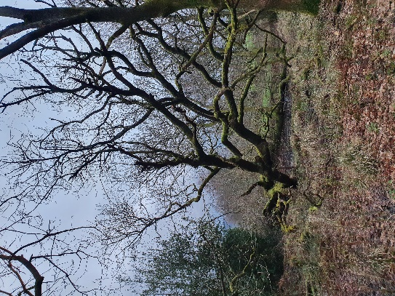

PROWS – PUBLIC RIGHTS OF WAY

Here in Salesbury we are incredibly lucky to have many miles of public footpaths, concessionary paths and bridleways to enjoy.
In partnership with the Peaks & Northern Footpath Society, local landowners & farmers, we are undertaking a long-term project to protect, improve and promote the PROWs within Salesbury Parish. This will include improved signage, replacing & repairing stiles, improving access and educating people about using PROWs considerately.We are currently applying for grants to help us with costs, but we have already made a start with improving signage. Keep a look out on your walks for our new, unique boot signs on stiles and gateways. These will point you in the right direction and also show the path number so that those who enjoy a challenge can tick off all 32 of the official PROWs in the parish. You can find all PROWs in the area at
Please keep an eye on our new website http://www.salesburypc.org.uk/ for progress
Report It!
Lancashire County Council is responsible for issues such as missing or damaged road signage; road markings; streetlighting; potholes; problems with public footpaths & rights of way; blocked road drains; overgrown vegetation on road verges and anything causing road obstructions such as fallen trees. Response times vary depending on the nature and severity of the problem.
Please report via the new ‘Love Clean Streets’ app available from the App store or Google Play or via PC at https://www.lancashire.gov.uk/roads-parking-and-travel/report-it/
Ribble Valley Borough Council continue to be the point of contact for planning & licensing applications and also for reporting issues such as fly tipping, waste collection, dog fouling. Registering with a new facility on their website enables you to report these issues quickly and easily https://ribblevalleygov-self.achieveservice.com/en or you can call their office on 01200 425111.
If the problem affects Salesbury Parish, please also let us know via Lesley, our Clerk.

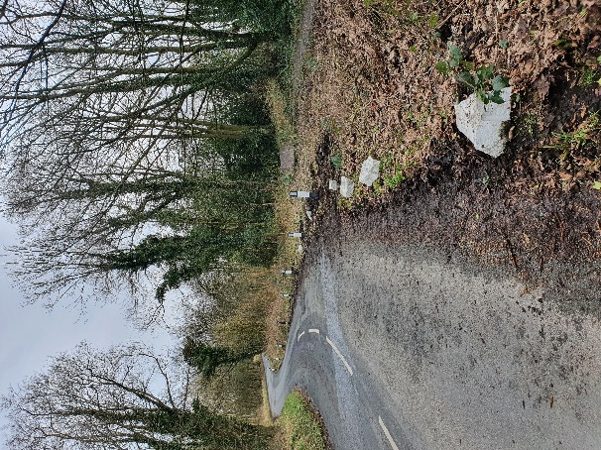
Way-markers

The eagle eyed amongst you may have noticed new way-markers on Lovely Hall Lane. These were installed by our councillors following consultation with both LCC and RVBC. Previously, vehicles were using the verges both to park on and, unbelievably, as a turning circle on this particularly bad bend. The new way-markers will help protect this section of the common as well as preventing inconsiderate and dangerous practices by drivers.

Ash Die Back and Non-Native Invasive Weeds

RVBC is responsible for dealing with these issues on common land. The countryside officers are already actively managing cases of Japanese Knotweed and American Skunk Cabbage within the parish and they have also been made aware of affected trees which may pose a risk to walkers, paths and roads.
We really appreciate reports from residents about these issues, please continue to report anything you spot.

Street Lamp repair
Thanks to Lancashire County Council for fixing the leaning street lamp on Copster Green. If you see any problems on either the Highways or with street lamps, please report them to Lancashire County Council or one of your Parish Councillors who would be more than happy to report the fault.
Planters
It was decided by the Parish Council to keep the adoption scheme and a reminder that £25 per planter is available to be claimed for any plants soil etc bought in order to make the area look beautiful.
******************************************************************************************************
School Parking - One way system
The Parish Council is sure that residents are all aware of the traffic situation at Salesbury school at drop off and pick up times.
The Parish Council would like to see the ‘ left turn only ‘ signs on the car park made obligatory and this item will be discussed at the next meeting in connection with contacting Lancashire County Council in relation to this matter. If this scheme were approved it would certainly ease the congestion on the Ribchester Road side of the school and would not effect traffic travelling from the A59. Keep up to date by looking on the Parish website for progress.

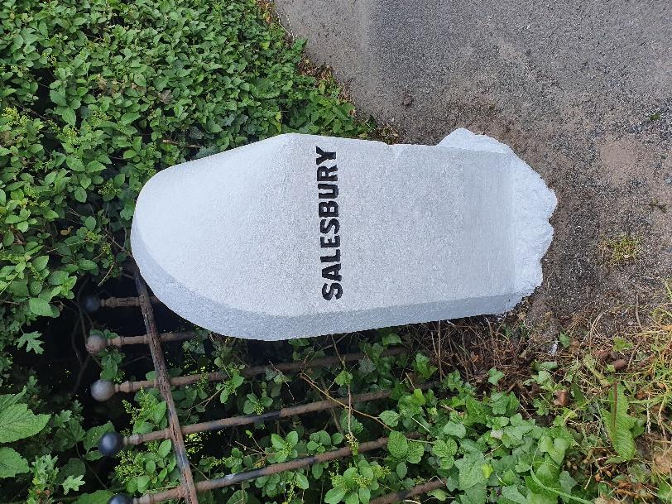
Salesbury Milestone
Recently given a little refurbishment by Cllr Henderson.

Speeding A59
Earlier this year residents approached the Parish Council with concerns about vehicles overtaking dangerously when leaving the 40mph speed limit heading towards Clitheroe along the A59. The Parish Council raised the issue with officers from Lancashire County Council when members attended a Highways Conference at County Hall in Preston, as a result we have been promised a site visit by the Safety Team from Lancashire County Council. Unfortunately, we are still waiting for this visit to happen, we are continuing to chase them and have now asked the County Councillor for our area to help.
Bridlepaths - Planings
Lancashire County Council have kindly offered to supply us with some road planings in early summer completely free of charge – which will have hopefully been delivered when you are reading this newsletter. These will be used to fill the many potholes we have on the various major bridlepaths within the Parish. As with previous remedial work, it will only be a temporary. If it works well, subject to Lancashire County Council being able to supply more in the future, we will look to fill them on a regular basis.
SUMMARY OF VOTES AND ALL ADDITIONAL COMMENTS FROM THE 2022 RESIDENTS SURVEY.

Thanks to everyone who took the time to respond to our survey, we had 40 responses which we believe is the most ever returned and they had over 140 separate suggestion/comments within them (many of which covered the same topics). It has been fantastic to read through them, whilst we won’t be able to action all of the suggestions we will endeavour to do as many of them as possible and as quickly as possible.

If you have a specific question about any comment you made, please contact Lesley Lund or pop to one of our Surgeries and have a chat with us over a cup of tea/coffee. Whilst it is a more formal setting, you are also more than welcome to attend any of our Parish Council meetings where you will be able to address the Council directly in the ‘Public Participation’ section.

The areas which received the most comments on were:-

- Speeding on the A59, the bridlepaths and Lovely Hall Lane.
- Some excellent suggestions on how we can sympathetically protect the Common Areas. At our next meeting with Ribble Valley Borough Council we will put them forward, and report back at our next Parish Council meeting.
- Filling of potholes. Please the section on Potholes within this newsletter for the latest update.
- School parking on Lovely Hall Lane
- Cricket Club users parking on Hazel Moor
- Maintenance of footpaths
- Extension of footpath on Lovely Hall Lane
- The protection of the various Common areas.

The results of the survey where residents were invited to vote were as follows:

Question 1 - How would you like us to communicate with you?

Leaflets 25 votes
Noticeboards 17 votes
Website 15 votes
Social media 3 votes
Other 5 votes

We propose to continue using Leaflets, Noticeboards and the website as our tools for communicating.

____________________________

Vegetation on Copster Green

Question 2 (a) - Should we pay for a survey in order to enable the area of vegetation on Copster Green to be tackled sympathetically?

Yes 20 votes
No 17 votes
No answer 3

Question 2 (b) - Going forward, should this area be pruned & properly managed, left alone to spread or removed completely?

Managed 25 votes
Left alone 9 votes
Removed 4 votes
Other 1
No answer 1

We propose to progress with the survey and once Ribble Valley give us the go-ahead, we will trim it back and then continue with its ongoing management.

____________________________

Question 3 - Jubilee Pathway. Do you think that an additional path in this area is good idea?

Yes 32 votes
No 6 vote
Other 2 votes

We propose to continue with the project, working closely with Ribble Valley Borough Council and all other interested parties.

____________________________

Question 4 - Do you think drop-in surgeries where you can speak with us directly are a good idea?

Yes 34 votes
No 3 votes
Other 2 votes
No answer 1

We propose to organise the next one for Monday 12th September at 7pm at the Memorial Hall.

____________________________

Question 5 - Projects and displays. Going forward, would you like Salesbury Parish Council to keep funding & creating these, and similar displays?

Yes 33 votes
No 5 votes
Other 2 votes

We propose to continue to fund Community Projects and displays.

____________________________

Further Defibrillator Awareness Sessions

Question 6 (a) - Would you like to see more sessions arranged?

Yes 26 votes
No 6 votes
Other 6 votes
No answer 2

We propose to organise another session in the autumn.

Question 6 (b) - Are there other public awareness topics you would like to be covered?

Yes 7 votes (suggestions offered)
No 14 votes
No answer 19

Thank you to those who put suggestions forward, because of the lack of interest, we will include this question in next years survey.

____________________________

Question 7 - Would you like us to continue to try to get a Book Swap Hub set up within the Parish?

Yes 19 votes
No 15 votes
Other 6 votes

We will continue to explore possible sites with both LCC and Ribble Valley Borough Council with the hope that we can get some agreement for next spring. In the meantime, subject to the weather there is a small book swap box outside Copster House on Copster Green.

____________________________

Question 8 - Protection of Common areas. Do you believe the edges of common land should be protected to prevent damage and erosion?

Yes 32 votes
No 5 votes
Other 3 votes

The summary of the suggestions to protect the Commons will be put to Ribble Valley Borough Council, who ultimately are responsible for the management of the Commons.

____________________________

Question 9 (a) and (b) was for suggestions only

____________________________

Question 10 - Do you think Salesbury Parish Council represents good value for money?

Yes 30 votes
No 5 votes
No answer 5

Thank you for the huge amount of positive comments you gave us, it’s very much appreciated by us all.

Jubilee – one of our benches painted red white and blue ! Thanks to
Cllr Henderson
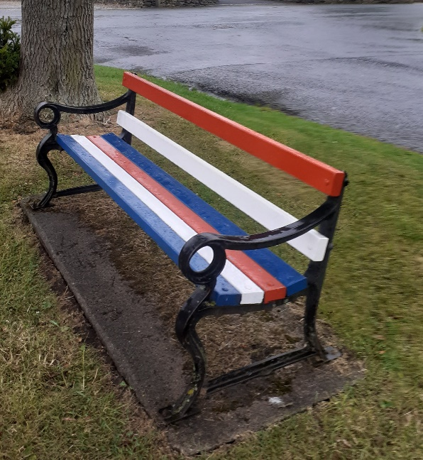

SPC Newsletter issue 3, Summer 2022 - Edited by Lesley Lund

