
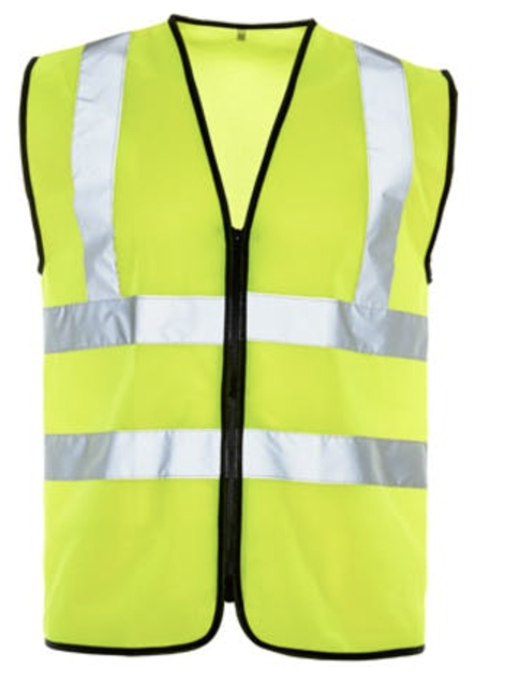
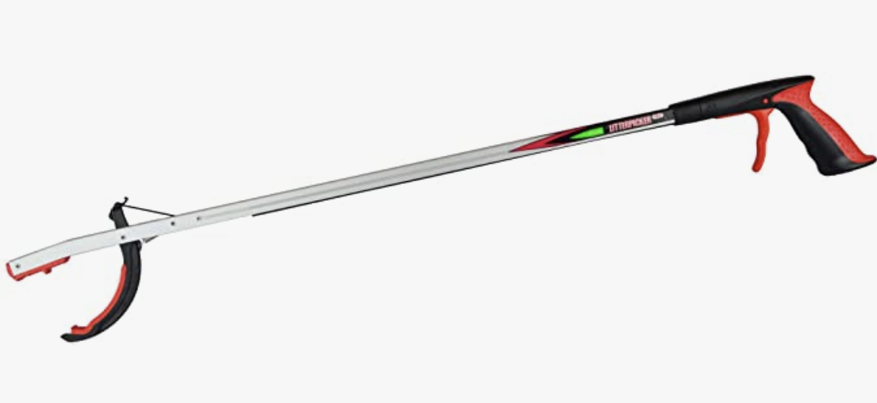
Salesbury Parish Council
Our litter needs picking.
No ongoing commitment needed
Just borrow a picker and hi-vis jacket, return them when you’ve picked.
Bags also available.

Please contact
any Councillor

